Assignment 2
Use Python/R/Matlab coding – Do not directly use software for linear regression – You may check your answers (validate) by using a software after coding
Due Date: 6th April 2026 (No extensions permitted)
Question-1:
Reference: Kutner, M. H., C. J. Nachtschiem, J. Netner, Applied Linear Regression Models. 4th ed. New Delhi: McGraw Hill, 2004.
A researcher studied the effects of the charge rate and temperature on the life of a new type of power cell in a preliminary small-scale experiment. The charge rate (X₁) was controlled at three levels (0.6, 1.0, and 1.4 amperes) and the ambient temperature (X₂) was controlled at three levels (10, 20, 30°C). Factors pertaining to the discharge of the power cell were held at fixed levels. The life of the power cell (Y) was measured in terms of the number of discharge-charge cycles that a power cell underwent before it failed. The data obtained in the study are given below:
Lifecycle (Y) | Charge Rate (X₁) | Temperature (X₂)
144 | 0.6 | 10
89 | 1.0 | 10
59 | 1.4 | 10
278 | 0.6 | 20
167 | 1.0 | 20
141 | 1.0 | 20
164 | 1.0 | 20
129 | 1.4 | 20
259 | 0.6 | 30
245 | 1.0 | 30
214 | 1.4 | 30
The researcher was not sure about the nature of the response function in the range of the factors studied. Hence, the researcher decided to fit the second-order polynomial regression model as follows:
$Y_{i}= β_{0}+ β_{1}x_{\left\{i1\right\}}+ β_{2}x_{\left\{i2\right\}}+ β_{\left\{11\right\}}x_{\left\{i1\right\}}^{2}+ β_{\left\{22\right\}}x_{\left\{i2\right\}}^{2}+ β_{\left\{12\right\}}x_{\left\{i1\right\}}x_{\left\{i2\right\}}+ ε_{i}$ (1)
for which the response function is:
$E\left(Y\right)= β_{0}+ β_{1}x_{1}+ β_{2}x_{2}+ β_{\left\{11\right\}}x_{1}^{2}+ β_{\left\{22\right\}}x_{2}^{2}+ β_{\left\{12\right\}}x_{1}x_{2}$ (2)

Write a code (using R/Python/MATLAB) to find the following:
i. Create a matrix “X” for raw data
ii. Create matrix “x” for data such that $x= \frac{X-μ}{Step size}$
iii. Create a matric “z” such that $z= \frac{X-μ}{\max\left(X\right)-min⁡(X)}$
iii. Find regression coefficients for the three different cases (X, x, and z).
iv. Find residual sum of squares, regression sum of squares, total sum of squares. Use both Matrix and summation approaches and compare them. Do the values change depending upon the transformation?
v. Find the variance-covariance matrix in all cases and compare the matrices for the transformed(x,z) and non-transformed (X) cases. Which is better in terms of precision of the regression coefficient estimates?
vi. Find R², adj. R², PRESS, R² _{PRESS} for all the cases.
Write code for finding PRESS and R²_{PRESS} in all the three cases.
[30]

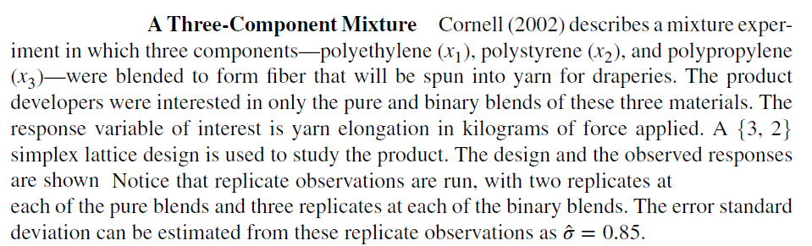
Question 2

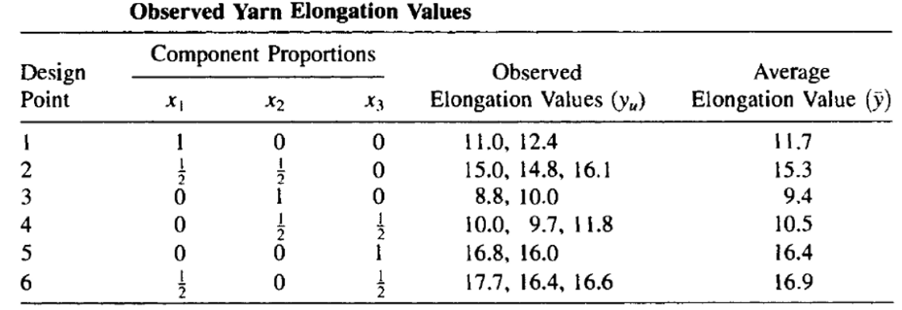

Use your own Matlab/Python code – you may modify the previously given code for this problem
- How is this mixture regression problem different from conventional linear regression?
- Give the $X$ matrix, $\hat{β}$and Y matrices/vectors
- Estimate the parameters
- Find the total, regression and error sum of squares
- What is the source of the error? Why is it called pure error?
- Estimate the total, regression and error sum of squares using direct matrix manipulations and conventional summation methods
- Find the variance covariance matrix
- Find the R², adj. R², PRESS and R2 Press
- Find the settings that will maximize Yarn Elongation (write constrained optimization code for this)
- Find the settings that will minimize Yarn Elongation (write constrained optimization code for this)
- Confirm your results using a standard software like Polymath, Minitab, or JMP
[2+3+6+2+6+2+8+4+4+3]

Question 3
The programming example discussed in class is to be solved using the code. Find the parameters of the 1-predictor logistic regression model and compare the predicted probabilities with the actual binary inputs. Use Matlab/Python coding.
Compare your answers with JMP/Minitab if possible.
[15]
Question 4
The dark chocolate example data is given below. Now develop the logistic models for the given data using product of Bernoulli outcomes
- Only income as the predictor
- Both income as well as gender as predictors
- Compare your answers with JMP/Minitab if possible.

Data is given in terms of sl. No., income (in thousands of euros), gender (0-female, 1-male), decision (0-not urchased, 1- purchased)
[25]

Table 2. Data for Programming Experience versus Task Completion
Experience | y | y_Pred
14 | 0 | 0.310262
29 | 0 | 0.835263
6 | 0 | 0.109996
25 | 1 | 0.726602
18 | 1 | 0.461837
4 | 0 | 0.08213
18 | 0 | 0.461837
12 | 0 | 0.245666
22 | 1 | 0.620812
6 | 0 | 0.109996
30 | 1 | 0.856299
11 | 0 | 0.21698
30 | 1 | 0.856299
5 | 0 | 0.095154
20 | 1 | 0.542404
13 | 0 | 0.276802
9 | 0 | 0.1671
32 | 1 | 0.891664
24 | 0 | 0.693379
13 | 1 | 0.276802
19 | 0 | 0.502134
4 | 0 | 0.08213
28 | 1 | 0.811825
22 | 1 | 0.620812
8 | 1 | 0.145815

[10]
Table 2. Data for Dark Chocolate Buying Trend in terms of Income and gender
Data_Expt = [
1 2.53 0 1
2 2.37 1 0
3 2.72 1 1
4 2.54 0 0
5 3.20 1 1
6 2.94 0 1
7 3.20 0 1
8 2.72 1 1
9 2.93 0 1
10 2.37 0 0
11 2.24 1 1
12 1.91 1 1
13 2.12 0 1
14 1.83 1 1
15 1.92 1 1
16 2.01 0 0
17 2.01 0 0
18 2.23 1 0
19 1.82 0 0
20 2.11 0 0
21 1.75 1 1
22 1.46 1 0
23 1.61 0 1
24 1.57 1 0
25 1.37 0 0
26 1.41 1 0
27 1.51 0 0
28 1.75 1 1
29 1.68 1 1
30 1.62 0 0 ];

Data also given as excel file in book resources and image reproduced below
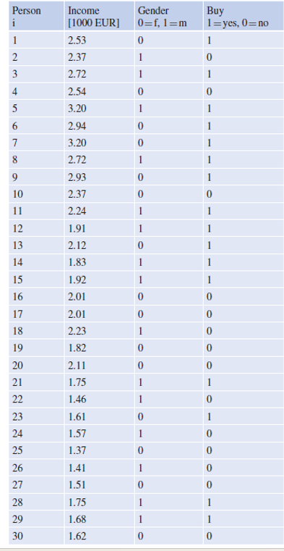

Question 5
In a study of the effectiveness of coupons offering a price reduction on a given product, 1,000 homes were selected at random. A packet containing advertising material and a coupon for the product were mailed to each home. The coupons offered different price reductions (5, 10, 15, 20, and 30 dollars), and 200 homes were assigned at random to each of the price reduction categories. The predictor variable X in this study is the amount of price reduction, and the response variable Y is a binary variable indicating whether or not the coupon was redeemed within a six-month period.
Table 14.2 contains the data for this study. X _{j} denotes the price reduction offered by
a coupon, n _{j} the number of households that received a coupon with price reduction X_{j} , Y_{. j} the number of these households that redeemed the coupon, and p_{j} the proportion of households receiving a coupon with price reduction X _{j} that redeemed the coupon. The logistic regression model is to be fitted by a logistic regression model

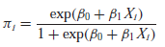
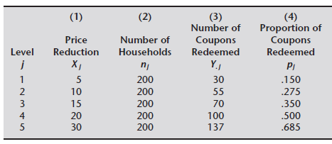
Compare the predicted probabilities with actual proportions observed.
[15]
Question 6
You have done Binomial distribution of grouped data involving repeated predictors. You estimated parameters using this data set. Now ungroup the dataset but use repeated averaged income predictor values instead of actual income values. The response values remain as given. Hence, the dataset is given as follows
Income | y
2.717 | 1
2.717 | 0
2.717 | 1
2.717 | 0
2.717 | 1
2.717 | 1
2.562 | 1
2.562 | 1
2.562 | 1
2.562 | 0
2.562 | 1
2.562 | 1
2.02 | 1
2.02 | 1
2.02 | 1
2.02 | 0
2.02 | 0
2.02 | 0
1.72 | 0
1.72 | 0
1.72 | 1
1.72 | 0
1.72 | 1
1.72 | 0
1.556667 | 0
1.556667 | 0
1.556667 | 0
1.556667 | 1
1.556667 | 1
1.556667 | 0

Now use Bernoulli trials based MLE method the find the logistic regression model parameters. Compare them with the parameters estimated from Binomial trials based MLE model parameters using grouped data of repeated predictors.
[10]
Question 7
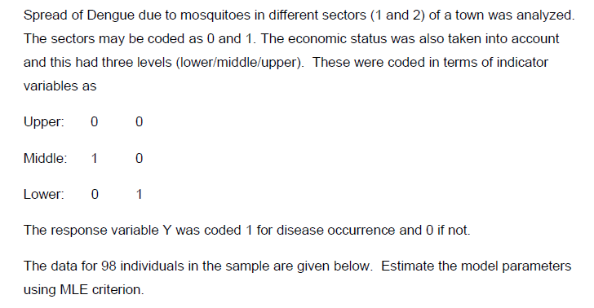
For downloading data use the following link
http://www.cnachtsheim-text.csom.umn.edu/Kutner/Chapter%2014%20Data%20Sets/CH14TA03.txt

City sector is also a categorical variable. Since there were only two sectors in the study, one indicator variable (X₄) was used, defined so that X₄ = 0 for sector 1 and X₄ = 1 for sector 2.
The reason why the upper socioeconomic class was chosen as the reference class (i.e., the class for which the indicator variables X₂ and X₃ are coded 0) is that itwas expected that this classwould have the lowest disease rate among the socioeconomic classes. By making
this class the reference class, the odds ratios associated with regression coefficients β₂
and β3 would then be expected to be greater than 1, facilitating their interpretation. For the
same reason, sector 1, where the epidemic was less severe, was chosen as the reference
class for the sector indicator variable X₄. Note the use of the indicator variables as just explained for the two categorical variables. The primary purpose of the study was to assess the strength of the association between each of the predictor variables and the probability of a person having contracted the disease.
Y = β₀ + β₁X₁ + β₂X₂ + β₃X₃ + β₄X₄

